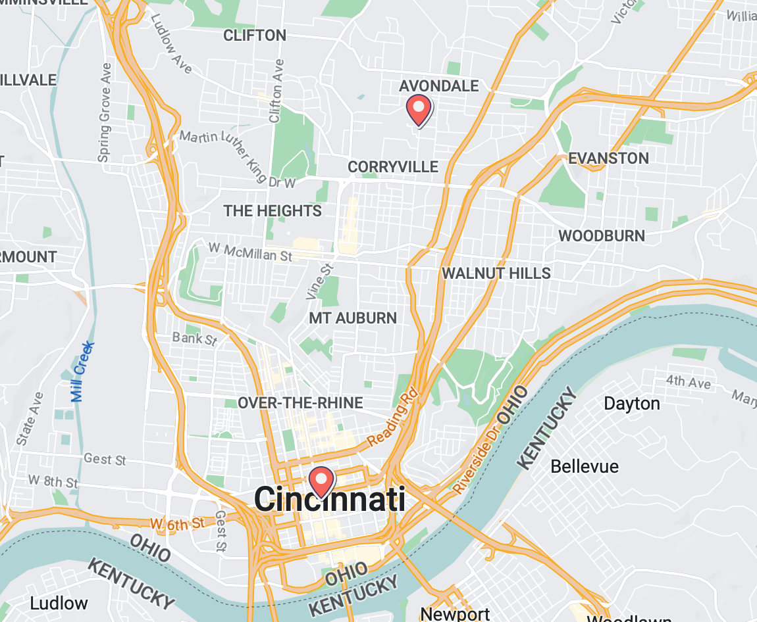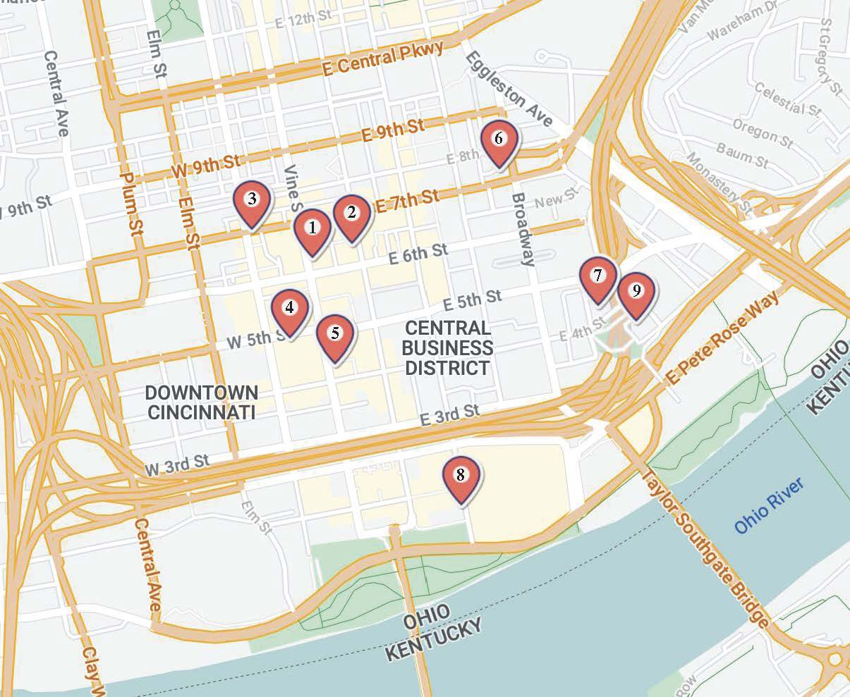

#

*

1 – CCHMC Pink Shuttle Stop

24 E. 6th St.

Distance From CCHMC: 3.2mi

2 – [21C Museum Hotel](https://www.21cmuseumhotels.com/cincinnati/)

Distance From Pink Shuttle Stop: 0.1mi

Distance From CCHMC: 3.3mi

Price Per Night: $300 - $450

3 – [Kinley Cincinnati Downtown, a Tribute Portfolio Hotel](https://www.marriott.com/en-us/hotels/cvgtx-kinley-cincinnati-downtown-a-tribute-portfolio-hotel/overview/?scid=f2ae0541-1279-4f24-b197-a979c79310b0)

Distance From Pink Shuttle Stop: 0.2mi

Distance From CCHMC: 3.6mi

Price Per Night: $250 - $350

4 – [Hilton Cincinnati Netherland Plaza](https://www.hilton.com/en/hotels/cvgnphf-hilton-cincinnati-netherland-plaza/?SEO_id=GMB-AMER-HH-CVGNPHF&y_source=1_MTIyMDg3Ni03MTUtbG9jYXRpb24ud2Vic2l0ZQ%3D%3D)

Distance From Pink Shuttle Stop: 0.2mi

Distance From CCHMC: 3.4mi

Price Per Night: $250 - $350

5 – [Courtyard by Marriott Cincinnati Downtown](https://www.marriott.com/en-us/hotels/cvgct-courtyard-cincinnati-downtown/overview/?scid=f2ae0541-1279-4f24-b197-a979c79310b0)

Distance From Pink Shuttle Stop: 0.2mi

Distance From CCHMC: 3.4mi

Price Per Night: $220 - $350

6 - [Holiday Inn & Suites Cincinnati Downtown an IHG Hotel](https://www.ihg.com/holidayinn/hotels/us/en/cincinnati/cvghs/hoteldetail?cm_mmc=GoogleMaps-_-HI-_-US-_-CVGHS)

Distance From Pink Shuttle Stop: 0.4mi

Distance From CCHMC: 2.8mi

Price Per Night: $200 - $300

7 – [Residence Inn Cincinnati Downtown/The Phelps](https://www.marriott.com/en-us/hotels/cvgcd-residence-inn-cincinnati-downtown-the-phelps/overview/?scid=f2ae0541-1279-4f24-b197-a979c79310b0)

Distance From Pink Shuttle Stop: 0.6mi

Distance From CCHMC: 3.0mi

Price Per Night: $250 - $350

8 – [AC Hotel Cincinnati at The Banks Marriott](https://www.marriott.com/en-us/hotels/cvgbc-ac-hotel-cincinnati-at-the-banks/overview/?scid=d6ce4213-8c0e-4598-aad9-9d23b476ba58&gclid=EAIaIQobChMIzIOjs6OT_wIVJoxMCh1Z9wg8EAAYASAAEgIBmfD_BwE&gclsrc=aw.ds)

Distance From Pink Shuttle Stop: 0.6mi

Distance From CCHMC: 3.4mi

Price Per Night: $300 - $400

9 – [The Lytle Park Hotel, Autograph Collection](https://www.marriott.com/en-us/hotels/cvgak-the-lytle-park-hotel-autograph-collection/overview/?scid=f2ae0541-1279-4f24-b197-a979c79310b0)

Distance From Pink Shuttle Stop: 0.7mi

Distance From CCHMC: 3.1mi

Price Per Night: $400 - $550

*[Cincinnati Children’s Hospital Medical Center (CCHMC)](https://www.cincinnatichildrens.org/)

3333 Burnet Ave, Cincinnati OH 45229

# [Graduate Hotel](https://www.graduatehotels.com/cincinnati/)

151 Goodman Dr, Cincinnati, OH 45219

Distance From CCHMC: 0.3mi (walkable)

Price Per Night: Special Discount Rate with SCGDB